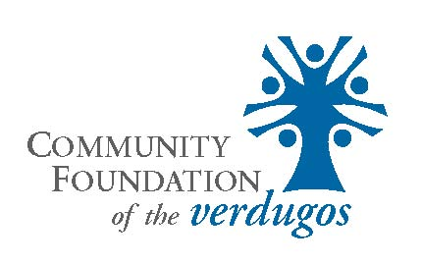
2023 Grant Application
Please use Microsoft Word format -
Email completed application with attachments by midnight of the Deadline (June 15, 2023) to Grants@cfverdugos.org

During the 2023 grant cycle, the Community Foundation of the Verdugos (CFV) is accepting requests from any 501(c)(3) that provides services in the Verdugo Region. This is an open, competitive cycle enabling nonprofits to request funding for the most important needs that include impact and improve the quality of life in the Verdugo region. If your agency received a grant from the CFV's 2022 grant cycle, you are able to apply again this year with a different request that complies with the CFV's 2023 grant guidelines.

Name of Agency:

Year Established:

Monetary Amount Requested:
(If approved, a follow-up report is due within 6 months of the approved grant date)

Contact Name & Title:

Agency/Contact Address:

City: State: Zip:

Agency/Contact Phone:

Agency/Contact Fax:

Agency Website:

Agency/Contact Email:

#1 Grant Request (briefly state the need your funding is for. You can provide detail in the next question):

#2 Summary Statement of Grant Request (explain in 200 words or less more about the request stated in Question #1):

#3 Problem Statement/Needs Assessment of the Grant Request (200 words or less):

#4 Objectives & Methods regarding the Grant Request (200 words or less):

#5 Explain how you will evaluate the success of any approved funding (200 words or less):

#6 Other Funding Sources for the Grant Request Amount Approved?

#7 Future Funding Sources/Plan for Sustainability (200 words or less):

#8 If your agency received funding from the CFV in the past, when was the most recent grant according, and its purpose, according to your records:

#9 Agency Information – include numbers/percentages that your mission impacts, indicating service to those in the Verdugo region (200 words or less)

Your Application is not yet complete!
The following is a Check-List of Attachments in addition to your application:

• Program/Project Budget for the request. For capital items, include a copy of bids/estimates or other research indicating cost of the capital item.

• For First-time Applicants, OR those who have never received funding from the CFV, OR if it has been longer than 5 years since your agency received a grant from the CFV, please include no more than two letters of reference in support of the grant request or your agency and its work.

• List of names and positions of paid professional staff/key personnel related to the request. Please include a sentence explaining their expertise/duties.

• List of your Board of Directors, their business affiliation(s), and whether they contribute/donate personally to your agency. Ideally, we are looking for 100% Board support for your agency.

• Copy of your agency’s Federal and State nonprofit determination letters.

• Signed Resolution from Board of Directors or Governing Board (see the following page for this form).

Please note that CFV staff will confirm IRS compliance and nonprofit status by accessing filed 990 data to review your agency’s most recent filing. DO NOT include a copy of your agency’s 990 with this application.

Email your completed application with attachments to grants@cfverdugos.org by midnight, Thursday, June 15, 2023

Email info@cfverdugos.org with questions
prior to the midnight deadline

Incomplete applications will not be considered.

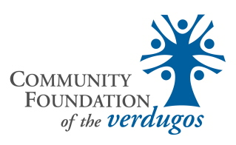

Resolution from Board of Directors or Governing Board

The following Resolution MUST be signed by an AUTHORIZED BOARD OFFICER which will indicate that the Resolution has been adopted.

BE IT RESOLVED that the attached application of this corporation to the Community Foundation of the Verdugos for a grant in the amount of $__________ to be used for ________________________ is hereby approved; and BE IT FURTHER RESOLVED that in the event the grant is made, either in whole or in part, the funds so granted will be used solely for the purpose specified above, and any funds, over $20.00 not expended, will be returned to the Community Foundation of the Verdugos.

In addition, this application must be signed by the chief executive officer or executive director to whom future questions and correspondence may be addressed. Submission of an application indicates your agency’s permission for Community Foundation of the Verdugos to make an independent inquiry about your agency’s board, staff, and others with whom you are affiliated. Signatories attest to the accuracy of the information.

Name of Agency:

Name: Name:

Title of Board Officer: Title of Agency Officer:

Date: Date:

Signature _____________________________ Signature _____________________________

